Make artful sketchbooks

- Gather white papers (I recommend 12”x18”)
If you have small size of papers, then just stack and staple them together. 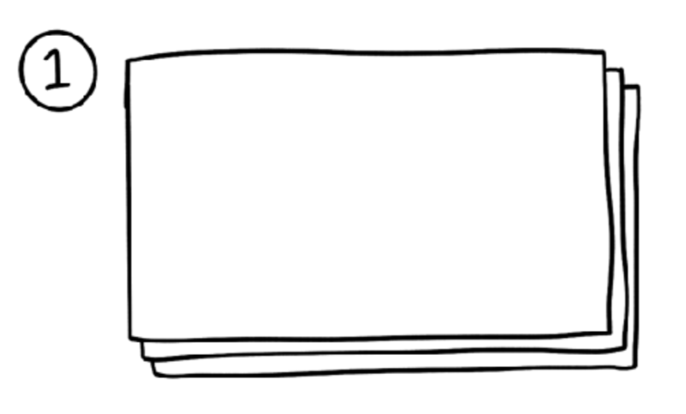
- Fold each of your sheets of paper horizontally. 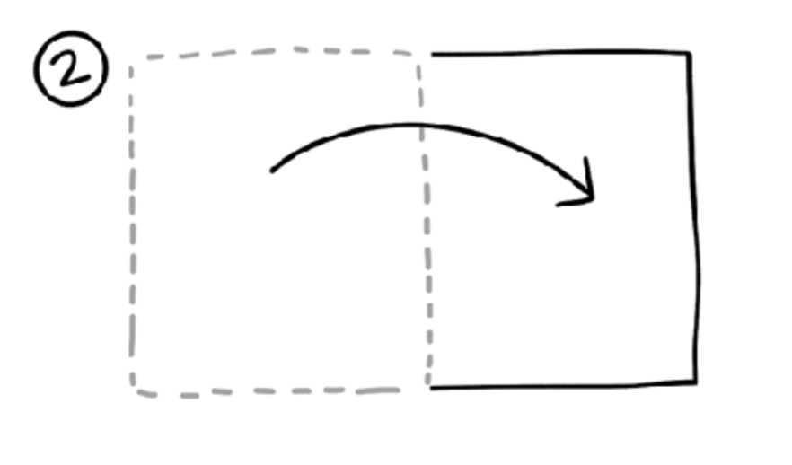
- Open your folded sheets of paper, stack them, and staple down the center of the fold.
- And now you have a sketchbook!
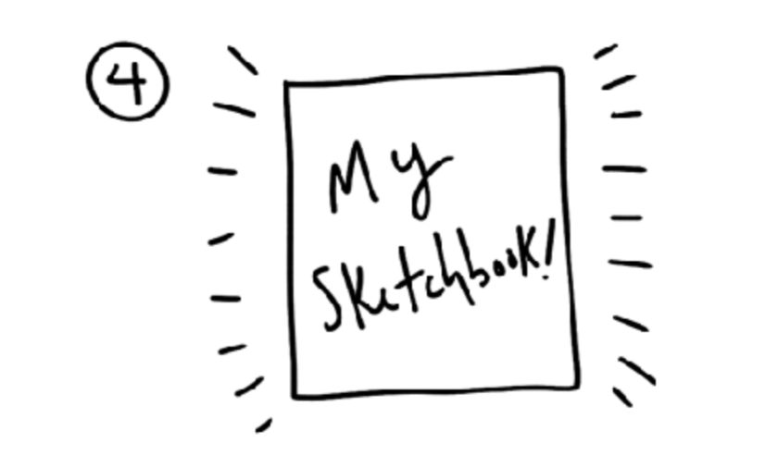

- Then have students decorate their covers with any subject that has colors
Examples:

